CS 131 THR
Group 1 Machine Problem 2
Bautista
Besas
Callado

  - Modified Euler’s Method

The source files used for obtaining the solution using modified euler’s method is in the FINAL_MODIFIED folder. To run, use the driverEMF.java file. This java file calls on Clare’s unmodified java methods in EulerModifiedFunction.java

Screenshots of the execution (using NetBeans):
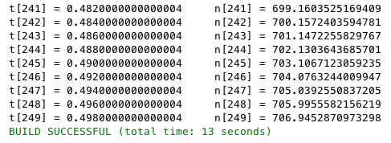
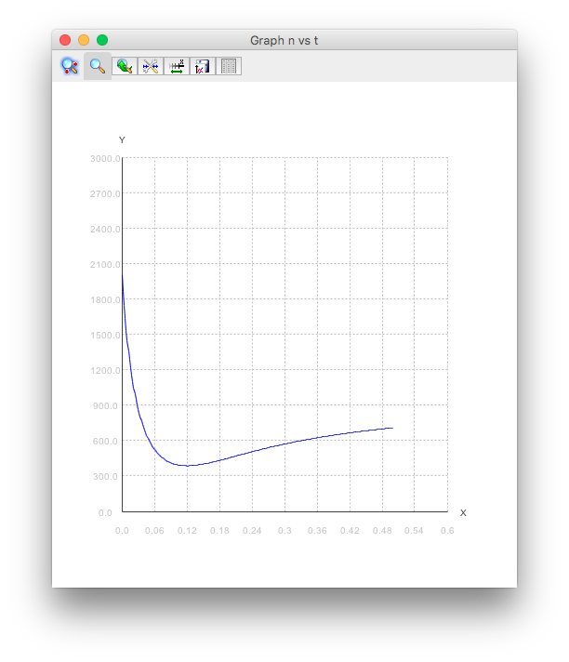
  - Implicit Euler’s Method + Newton’s Method

The source files used for obtaining the solution using Euler and Newton is in the FINAL_IMPLICIT folder. To run, use the EulerImplicit.java file. This java file calls on Louie’s unmodified java methods in NewtonRoot.java and Function.java

Screenshots of the execution (using NetBeans):
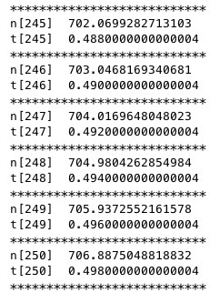
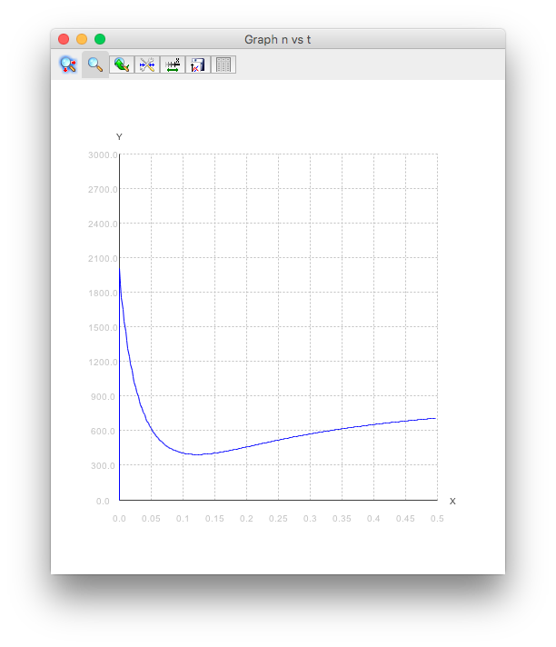
1.5
1. Yes, 20 iterations are enough. The graph resulting from using 20 iterations does not have an apparent difference from the graph that resulted from using 250 iterations.

2. Yes, the graphs look the same.

